Probability
Probability is the chance that something will happen - how likely it is that some event will happen over the long run.
Sometimes you can measure a probability with a number: "10% chance of rain", or you can use words such as impossible, unlikely, possible, even chance, likely and certain.
Example: "It is unlikely to rain tomorrow".
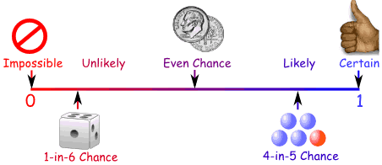

It can be shown as a fraction (not reduced is ok & usually more meaningful), decimal or percent.
**AP Exam-always show the ratio (fraction)!!

Between 0 and 1
- The probability of an event will not be less than 0.
This is because 0 is impossible (sure that something will not happen).
- The probability of an event will not be more than 1.
This is because 1 is certain that something will happen.

 | Meaning | Example 1 | Example 2
Experiment | A probabilistic experiment is simply the act of doing something and noting the outcome. | Flip a coin three times and observe the pattern of heads and tails. | Blindly throw a dart at a wall that is painted part red, part green, part blue, part white.
Outcome | The outcomes of an experiment are the results that can occur, described as specifically as possible. | HHH, HHT, HTH, HTT, THH, THT, TTH, TTT | Red, Green, Blue, White
Event | A set of outcomes. | "two tails" = {HHT, HTH, THH} | "dart hits a primary color" = {Red, Green, Blue}
Sample Space | The set of all possible outcomes. | {HHH, HHT, HTH, HTT, THH, THT, TTH, TTT} | {Red, Green, Blue, White}
Probability of an event. | The relative frequency of the event, when the experiment is performed many many times.  # favorable Outcomes  Total Outcomes | Assuming the coin is fair, each of the outcomes will occur roughly the same number of times in many repeats of the experiment.  The probability of "two tails" will be 3/8. | The probabilities of the different outcomes will depend on how much of the wall is covered by each color.  Area of red  Total Area

Probability: Complement
Complement of an Event: All outcomes that are NOT the event.
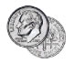 | When the event is Heads, the complement is Tails
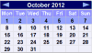 | When the event is {Monday, Wednesday} the complement is {Tuesday, Thursday, Friday, Saturday, Sunday}
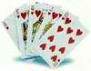 | When the event is {Hearts} the complement is {Spades, Clubs, Diamonds, Jokers}
So the Complement of an event is all the other outcomes (not the ones you want).
And together the Event and its Complement make all possible outcomes.
The probability of an event is shown using "P":
P(A) means "Probability of Event A"
The complement is shown by a little ' mark such as A' (or sometimes A^{c} for AP Stats):
P(A') means "Probability of the complement of Event A"
The two probabilities always add to 1
P(A) + P(A') = 1
So… P(A)=1- P(A') and P(A')=1-P(A)

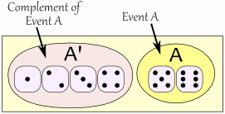

Example: Rolling a "5" or "6"
Event A: {5, 6}
Number of ways it can happen: 2
Total number of outcomes: 6
P(A) = | 2 | = | 1
 | 6 |  | 3

The Complement of Event A is {1, 2, 3, 4}
Number of ways it can happen: 4
Total number of outcomes: 6
P(A') = | 4 | = | 2
 | 6 |  | 3
Let us add them:
P(A) + P(A') = | 1 | + | 2 | = | 3 | = 1
 | 3 |  | 3 |  | 3
Yep, that makes 1
It makes sense, right? Event A plus all outcomes that are not Event A make up all possible outcomes.

Why is the Complement Useful?
It is sometimes easier to work out the complement first.
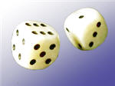

Example. Throw two dice. What is the probability the two scores are different?
Different scores are like getting a 2 and 3, or a 6 and 1. It is quite a long list:
A = { (1,2), (1,3), (1,4), (1,5), (1,6),
(2,1), (2,3), (2,4), ... etc ! }

But the complement (which is when the two scores are the same) is only 6 outcomes:
A' = { (1,1), (2,2), (3,3), (4,4), (5,5), (6,6) }
And the probability is easy to work out using an area model:
 | 1 | 2 | 3 | 4 | 5 | 6
1
2
3
4
5
6
Now create a list of combinations:

P(A') = 6/36 = 1/6
Knowing that P(A) and P(A') together make 1, we can calculate:
P(A) = 1 - P(A') = 1 - 1/6 = 5/6
So in this case it's easier to work out P(A') first, then find P(A)

Events
When we say "Event" we mean one (or more) outcomes.
Example Events:
- Getting a Tail when tossing a coin is an event
- Rolling a "5" is an event.
An event can include several outcomes:
- Choosing a "King" from a deck of cards (any of the 4 Kings) is also an event
- Rolling an "even number" (2, 4 or 6) is an event

Independent Events
Events can be "Independent", meaning each event is not affected by any other events.
This is an important idea! A coin does not "know" that it came up heads before ... each toss of a coin is a perfect isolated thing.
Example: You toss a coin three times and it comes up "Heads" each time ... what is the chance that the next toss will also be a "Head"?
The chance is simply 1/2, or 50%, just like ANY OTHER toss of the coin.
What it did in the past will not affect the current toss!
Some people think "it is overdue for a Tail", but really truly the next toss of the coin is totally independent of any previous tosses.
Saying "a Tail is due", or "just one more go, my luck is due" is called The Gambler's Fallacy

Dependent Events
But some events can be "dependent" ... which means they can be affected by previous events ...

Example: Drawing 2 Cards from a Deck
After taking one card from the deck there are less cards available, so the probabilities change!

Let's say you are interested in the chances of getting a King.
For the 1st card the chance of drawing a King is 4 out of 52
But for the 2nd card:
- If the 1st card was a King, then the 2nd card is less likely to be a King, as only 3 of the 51 cards left are Kings.
- If the 1st card was not a King, then the 2nd card is slightly more likely to be a King, as 4 of the 51 cards left are King.
This is because you are removing cards from the deck.
Replacement: When you put each card back after drawing it the chances don't change, as the events are independent.
Without Replacement: The chances will change, and the events are dependent.

Two or More Events
You can calculate the chances of two or more independent events by multiplying the chances.

Example: Probability of 3 Heads in a Row
For each toss of a coin a "Head" has a probability of 0.5:
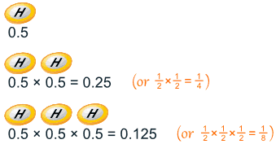
And so the chance of getting 3 Heads in a row is 0.125
So each toss of a coin has a ½ chance of being Heads, but lots of Heads in a row is unlikely.

Example: Why is it unlikely to get, say, 7 heads in a row, when each toss of a coin has a ½ chance of being Heads?
Because you are asking two different questions:
Question 1: What is the probability of 7 heads in a row?
Answer: ½×½×½×½×½×½×½ = 0.0078125 (less than 1%).
Question 2: Given that you have just got 6 heads in a row, what is the probability that the next toss is also a head?
Answer: ½, as the previous tosses don't affect the next toss.

Notation
We use "P" to mean "Probability Of",
So, for Independent Events:
P(A and B) = P(A) × P(B)
Probability of A and B equals the probability of A times the probability of B

Example: you are going to a concert, and your friend says it is some time on the weekend between 4 and 12, but won't say more.
What are the chances it is on Sunday between 10 and 12?
Day: there are two days on the weekend, so P(Sunday) = 0.5
Time: between 4 and 12 is 8 hours, but you want between 10 and 12 which is only 2 hours:
P(Your Time) = 2/8 = 0.25
And:
P(Sunday and Your Time) = P(Sunday) × P(Your Time) = 0.5 × 0.25 = 0.125
Or a 12.5% chance

Another Example
Imagine there are two groups:
- A member of each group gets randomly chosen for the winners circle,
- then one of those gets randomly chosen to get the big money prize:
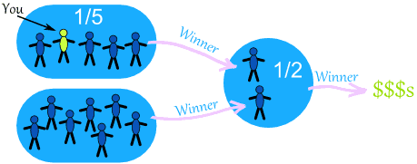
What is your chance of winnning the big prize?
- there is a 1/5 chance of going to the winners circle
- and a 1/2 chance of winning the big prize
So you have a 1/5 chance followed by a 1/2 chance ... which makes a 1/10 chance overall:
1 | × | 1 | = | 1 | = | 1
5 |  | 2 |  | 5 × 2 |  | 10
Or you can calculate using decimals (1/5 is 0.2, and 1/2 is 0.5):
0.2 x 0.5 = 0.1
So your chance of winning the big money is 0.1 (which is the same as 1/10).

Coincidence!
Many "Coincidences" are, in fact, likely.

Example: you are in a room with 30 people, and find that Zach and Anna celebrate their birthday on the same day.
Would you say "wow, how strange", or "that seems reasonable, with so many people here".
In fact there is a 70% chance that would happen ... so it is likely.
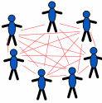 | Why is the chance so high?  Because you are comparing everyone to everyone else (not just one to many).  And with 30 people that is 435 comparisons

Example: Snap!
Did you ever say something the same as someone else, at the same time too?
Wow, how amazing!
But you were probably sharing an experience (movie, journey, whatever) and so your thoughts would be similar.
And there are only so many ways of saying something ...
... so it is like the card game "Snap!" ...
... if you speak enough words together, they will eventually match up.
So, maybe not so amazing, just simple chance at work.
Can you think of other cases where a "coincidence" was simply a likely thing?

Conclusion
- Probability is: (Number of ways it can happen) / (Total number of outcomes)
- Dependent Events (such as removing marbles from a bag) are affected by previous events
- Independent events (such as a coin toss) are not affected by previous events
- You can calculate the probability of 2 or more Independent events by multiplying
- Not all coincidences are really unlikely (when you think about them).

Mutually Exclusive Events
Mutually Exclusive: can't happen at the same time.
Examples:
- Turning left and turning right are Mutually Exclusive (you can't do both at the same time)
- Tossing a coin: Heads and Tails are Mutually Exclusive
- Cards: Kings and Aces are Mutually Exclusive
What is not Mutually Exclusive:
- Turning left and scratching your head can happen at the same time
- Kings and Hearts, because you can have a King of Hearts!
Like here:
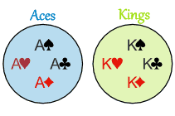 |  | 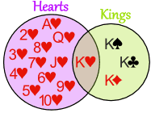
Aces and Kings are  Mutually Exclusive  (can't be both) |  | Hearts and Kings are  not Mutually Exclusive  (can be both)

Probability
Let's look at the probabilities of Mutually Exclusive events. But first, a definition:
Probability of an event happening = |  | Number of ways it can happen
 |  | Total number of outcomes
Example: there are 4 Kings in a deck of 52 cards. What is the probability of picking a King?
Number of ways it can happen: 4 (there are 4 Kings)
Total number of outcomes: 52 (there are 52 cards in total)
So the probability = | 4 | = | 1
 | 52 |  | 13

Mutually Exclusive
When two events (call them "A" and "B") are Mutually Exclusive it is impossible for them to happen together:
P(A and B) = 0
"The probability of A and B together equals 0 (impossible)"

But the probability of A or B is the sum of the individual probabilities:
P(A or B) = P(A) + P(B)
"The probability of A or B equals the probability of A plus the probability of B"

Example: A Deck of Cards
In a Deck of 52 Cards:
- the probability of a King is 1/13, so P(King)=1/13
- the probability of an Ace is also 1/13, so P(Ace)=1/13

When we combine those two Events:
- The probability of a card being a King and an Ace is 0 (Impossible)
- The probability of a card being a King or an Ace is (1/13) + (1/13) = 2/13
Which is written like this:
P(King and Ace) = 0
P(King or Ace) = (1/13) + (1/13) = 2/13

Special Notation
Instead of "and" you will often see the symbol ∩ (which is the "Intersection" symbol used in Venn Diagrams)
Instead of "or" you will often see the symbol ∪ (the "Union" symbol)
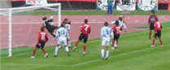

Example: Scoring Goals
If the probability of:
- scoring no goals (Event "A") is 20%
- scoring exactly 1 goal (Event "B") is 15%
Then:
- The probability of scoring no goals and 1 goal is 0 (Impossible)
- The probability of scoring no goals or 1 goal is 20% + 15% = 35%
Which is written:
P(A ∩ B) = 0
P(A ∪ B) = 20% + 15% = 35%

Remembering
To help you remember, think:
"Or has more ... than And"
∪ is like a cup which holds more than ∩

Not Mutually Exclusive
Now let's see what happens when events are not Mutually Exclusive.

Example: Hearts and Kings
Hearts and Kings together is only the King of Hearts:
But Hearts or Kings is:
- all the Hearts (13 of them)
- all the Kings (4 of them)
But that counts the King of Hearts twice!
So we correct our answer, by subtracting the extra "and" part:
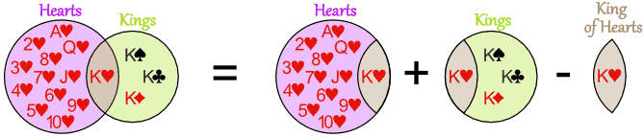
16 Cards = 13 Hearts + 4 Kings - the 1 extra King of Hearts
Count them to make sure this works!
As a formula this is:
P(A or B) = P(A) + P(B) - P(A and B)
"The probability of A or B equals the probability of A plus the probability of B
minus the probability of A and B"
Here is the same formula, but using ∪ and ∩:
P(A ∪ B) = P(A) + P(B) - P(A ∩ B)

A Final Example
16 people study French, 21 study Spanish and there are 30 altogether. Work out the probabilities!
This is definitely a case of not Mutually Exclusive (you can study French AND Spanish).
Let's say b is how many study both languages:
- people studying French Only must be 16-b
- people studying Spanish Only must be 21-b
And we get:
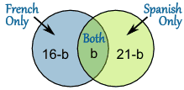
And we know there are 30 people, so:
(16-b) + b + (21-b) = 30
37 - b = 30
b = 7
And we can put in the correct numbers:
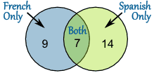
So we know all this now:
- P(French) = 16/30
- P(Spanish) = 21/30
- P(French Only) = 9/30
- P(Spanish Only) = 14/30
- P(French or Spanish) = 30/30 = 1
- P(French and Spanish) = 7/30
Lastly, let's check with our formula:
P(A or B) = P(A) + P(B) - P(A and B)
Put the values in:
30/30 = 16/30 + 21/30 – 7/30
Yes, it works!

Summary:

Mutually Exclusive
- A and B together is impossible: P(A and B) = 0
- A or B is the sum of A and B: P(A or B) = P(A) + P(B)

Not Mutually Exclusive
- A or B is the sum of A and B minus A and B: P(A or B) = P(A) + P(B) - P(A and B)

Probability Tree Diagrams
Calculating probabilities can be hard, sometimes you add them, sometimes you multiply them, and often it is hard to figure out what to do ... tree diagrams to the rescue!

Here is a tree diagram for the toss of a coin:
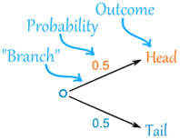 |  | There are two "branches" (Heads and Tails)  - The probability of each branch is written on the branch  - The outcome is written at the end of the branch
We can extend the tree diagram to two tosses of a coin:
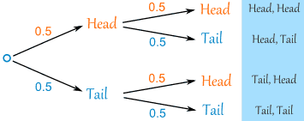
How do you calculate the overall probabilities?
- You multiply probabilities along the branches
- You add probabilities down columns
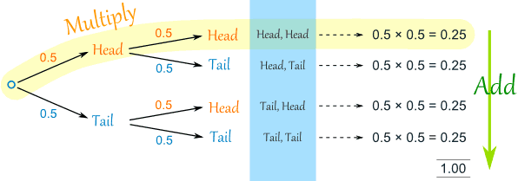
Now we can see such things as:
- The probability of "Head, Head" is 0.5×0.5 = 0.25
- All probabilities add to 1.0 (which is always a good check)
- The probability of getting at least one Head from two tosses is 0.25+0.25+0.25 = 0.75
- ... and more

That was a simple example using independent events (each toss of a coin is independent of the previous toss), but tree diagrams are really wonderful for figuring out dependent events (where an event depends on what happens in the previous event) like this example:

Example: Soccer Game
You are off to soccer, and love being the Goalkeeper, but that depends who is the Coach today:
- with Coach Sam the probability of being Goalkeeper is 0.5
- with Coach Alex the probability of being Goalkeeper is 0.3
Sam is Coach more often ... about 6 out of every 10 games (a probability of 0.6).
So, what is the probability you will be a Goalkeeper today?

Let's build the tree diagram. First we show the two possible coaches: Sam or Alex:
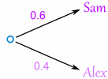
The probability of getting Sam is 0.6, so the probability of Alex must be 0.4 (together the probability is 1)
Now, if you get Sam, there is 0.5 probability of being Goalie (and 0.5 of not being Goalie):
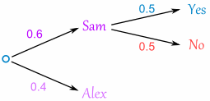
If you get Alex, there is 0.3 probability of being Goalie (and 0.7 not):
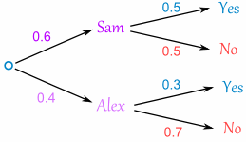
The tree diagram is complete, now let's calculate the overall probabilities. This is done by multiplying each probability along the "branches" of the tree.
Here is how to do it for the "Sam, Yes" branch:
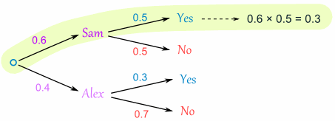
(When we take the 0.6 chance of Sam being coach and include the 0.5 chance that Sam will let you be Goalkeeper we end up with an 0.3 chance.)
But we are not done yet! We haven't included Alex as Coach:
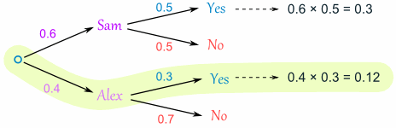
An 0.4 chance of Alex as Coach, followed by an 0.3 chance gives 0.12.
Now we add the column:
0.3 + 0.12 = 0.42 probability of being a Goalkeeper today
(That is a 42% chance)

Check
One final step: complete the calculations and make sure they add to 1:
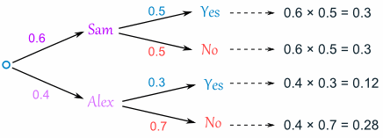
0.3 + 0.3 + 0.12 + 0.28 = 1
Yes, it all adds up.

Conclusion
So there you go, when in doubt draw a tree diagram, multiply along the branches and add the columns. Make sure all probabilities add to 1 and you are good to go.

Conditional Probability
How to handle Dependent Events
Life is full of random events! You need to get a "feel" for them to be a smart and successful person.

Independent Events
Events can be "Independent", meaning each event is not affected by any other events.

Example: Tossing a coin.
Each toss of a coin is a perfect isolated thing.
What it did in the past will not affect the current toss.
The chance is simply 1-in-2, or 50%, just like ANY toss of the coin.
So each toss is an Independent Event.

Dependent Events
But events can also be "dependent" ... which means they can be affected by previous events ...
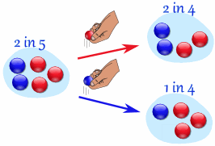

Example: Marbles in a Bag
2 blue and 3 red marbles are in a bag.
What are the chances of getting a blue marble?
The chance is 2 in 5
But after taking one out you change the chances!
So the next time:
- if you got a red marble before, then the chance of a blue marble next is 2 in 4
- if you got a blue marble before, then the chance of a blue marble next is 1 in 4
See how the chances change each time? Each event depends on what happened in the previous event, and is called dependent.
That is the kind of thing we will be looking at here.

"Replacement"
Note: if you had replaced the marbles in the bag each time, then the chances would not have changed and the events would be independent:
- With Replacement: the events are Independent (the chances don't change)
- Without Replacement: the events are Dependent (the chances change)

Notation
We love notation in mathematics! It means we can then use the power of algebra to play around with the ideas. So here is the notation for probability:
P(A) means "Probability Of Event A"
In our marbles example Event A is "get a Blue Marble first" with a probability of 2/5:
P(A) = 2/5
And Event B is "get a Blue Marble second" ... but for that we have 2 choices:
- If we got a Blue Marble first the chance is now 1/4
- If we got a Red Marble first the chance is now 2/4
So we have to say which one we want, and use the symbol "|" to mean "given":
P(B|A) means "Event B given Event A"
In other words, event A has already happened, now what is the chance of event B?
P(B|A) is also called the "Conditional Probability" of B given A.
And in our case:
P(B|A) = 1/4
So the probability of getting 2 blue marbles is:
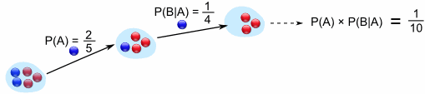
And we write it as
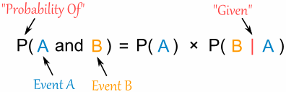
"Probability of event A and event B equals
the probability of event A times the probability of event B given event A"

Let's do the next example using only notation:

Example: Drawing 2 Kings from a Deck
Event A is drawing a King first, and Event B is drawing a King second.
For the first card the chance of drawing a King is 4 out of 52
P(A) = 4/52
But after removing a King from the deck the probability of the 2nd card drawn is less likely to be a King (only 3 of the 51 cards left are Kings):
P(B|A) = 3/51
And so:
P(A and B) = P(A) x P(B|A) = (4/52) x (3/51) = 12/2652 = 1/221
So the chance of getting 2 Kings is 1 in 221, or about 0.5%

Finding Hidden Data
Using Algebra we can also "change the subject" of the formula, like this:
Start with: |  | P(A and B) = P(A) x P(B|A)
Swap sides: |  | P(A) x P(B|A) = P(A and B)
Divide by P(A): |  | P(B|A) = P(A and B) / P(A)
And we have another useful formula:
$$P\left(B | A\right)=\frac{P(Both)}{P(Given)}$$
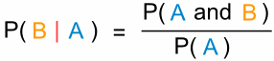
"The probability of event B given event A equals
the probability of event A and event B divided by the probability of event A

Example: Ice Cream
70% of your friends like Chocolate, and 35% like Chocolate AND like Strawberry.
What percent of those who like Chocolate also like Strawberry?
P(Strawberry|Chocolate) = P(Chocolate and Strawberry) / P(Chocolate)
0.35 / 0.7 = 50%
50% of your friends who like Chocolate also like Strawberry

False Positives and False Negatives

Test Says "Yes" ... or does it?
When you have a test that can say "Yes" or "No" (such as a medical test), you have to think:
- It could be wrong when it says "Yes".
- It could be wrong when it says "No".

Wrong?
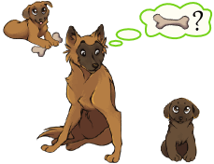 | It is like being told you did something when you didn't!  Or you didn't do it when you really did.
There are special names for this, called "False Positive" and "False Negative":
 | They say you did | They say you didn't
You really did | They are right! | "False Negative"
You really didn't | "False Positive" | They are right!
Here are some examples of "false positives" and "false negatives":
- Airport Security: a "false positive" is when ordinary items such as keys or coins get mistaken for weapons (machine goes "beep")
- Quality Control: a "false positive" is when a good quality item gets rejected, and a "false negative" is when a poor quality item gets accepted
- Antivirus software: a "false positive" is when a normal file is thought to be a virus
- Medical screening: low-cost tests given to a large group can give many false positives (saying you have a disease when you don't), and then ask you to get more accurate tests.
But many people don't understand the true numbers behind "Yes" or "No", like in this example:

Example: Allergy or Not?
Hunter says she is itchy. There is a test for Allergy to Cats, but this test is not always right:
- For people that really do have the allergy, the test says "Yes" 80% of the time
- For people that do not have the allergy, the test says "Yes" 10% of the time ("false positive")
Here it is in a table:
 | Test says "Yes" | Test says "No"
Have allergy | 80% | 20% "False Negative"
Don't have it | 10% "False Positive" | 90%

Question: If 1% of the population have the allergy, and Hunter's test says "Yes", what are the chances that Hunter really has the allergy?
Do you think 75%? Or maybe 50%?
A test similar to this was given to Doctors and most guessed around 75% ...
... but they were very wrong!
(Source: "Probabilistic reasoning in clinical medicine: Problems and opportunities" by David M. Eddy 1982, which this example is based on)
There are two good ways to work this out: "Imagine a 1000" and "Tree Diagrams".

Try Imagining A Thousand People
When trying to understand questions like this, just imagine a large group (say 1000) and play with the numbers:
- Of 1000 people, only 10 really have the allergy (1% of 1000 is 10)
- The test is 80% right for people who have the allergy, so it will get 8 of those 10 right.
- But 990 do not have the allergy, and the test will say "Yes" to 10% of them,
which is 99 people it says "Yes" to wrongly (false positive)
- So out of 1000 people the test says "Yes" to (8+99) = 107 people
As a table:
 | 1% have it | Test says "Yes" | Test says "No"
Have allergy | 10 | 8 | 2
Don't have it | 990 | 99 | 891
 | 1000 | 107 | 893
So 107 people get a "Yes" but only 8 of those really have the allergy:
8 / 107 = about 7%
So, even though Hunter's test said "Yes", it is still only 7% likely that Hunter has a Cat Allergy.

As A Tree
Drawing a tree diagram can really help:
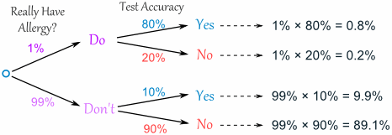
First of all, let's check that all the percentages add up:
0.8% + 0.2% + 9.9% + 89.1% = 100% (good!)
And the two "Yes" answers add up to 0.8% + 9.9% = 10.7%, but only 0.8% are correct.
0.8/10.7 = 7% (same answer as above)

Conclusion
When dealing with false positives and false negatives (or other tricky probability questions) it pays to:
- Imagine you have 1,000 (of whatever)
- Or make a tree diagram
PRACTICE #1
- A coin is tossed three times. Find the probability of getting at least two heads.

- A coin is tossed three times. Find the probability that head and tail show alternately.

- Two cards are drawn from the top of a well-shuffled deck. What is the probability that they are both black aces?

- A coin is tossed three times. What is the probability of getting two heads and one tail?

- A die is thrown twice. What is the probability both numbers are prime?

- A code consists of a digit chosen from 0 to 9 followed by a letter of the alphabet.
What is the probability the code is 9Z?

- A bag contains 5 red marbles, 4 green marbles and 1 blue marble.
A marble is chosen at random from the bag and not replaced; then a second marble is chosen. What is the probability both marbles are green?

- A bag contains 5 red marbles, 4 green marbles and 1 blue marble.
A marble is chosen at random from the bag and not replaced; then a second marble is chosen. What is the probability that neither marble is blue?

- Two cards are drawn from the top of a well-shuffled deck. What is the probability that they are both Diamonds?

- A code consists of a two digit number chosen from 00 to 99, followed by two different letters of the alphabet.
What is the probability the code is 12KY?
PRACTICE #2-Solve one by making Lists, one using an area model and one using a tree diagram.
- A baseball player hits 25% of the time. If he has 3 at bats, what are the odds that he gets exactly 2 hits? More than 2 hits? 0 or 1 Hit?

- Sheryl just bought a new wardrobe that consists of 3 shirts (yellow, red and green), 2 pairs of pants (white and denim) and 2 pairs of shoes (sandals and boots). How many outfits different can she make?

- Jim rolls a red die and a white die. He calculates the sum. What is sum is most likely? What are the chances he rolls the sum of 5? He rolls a prime number? A double? A sum of 1?

PRACTICE #3
- A bag contains 3 red marbles and 4 blue marbles. Two marbles are drawn at random without replacement.
If the first marble drawn is red, what is the probability the second marble is blue?

- A bag contains 3 red marbles and 4 blue marbles.
Two marbles are drawn at random without replacement.
If the first marble drawn is blue, what is the probability the second marble is also blue?

- Two cards are chosen at random without replacement from a pack of 52 playing.
If the first card chosen is an Ace, what is the probability the second card chosen is a King?

- Two cards are chosen at random without replacement from a pack of 52 cards.
If the first card chosen is an Ace, what is the probability the second card chosen is also an Ace ?

- A box contains 5 green pencils and 7 yellow pencils. Two pencils are chosen at random from the box without replacement.
What is the probability they are both yellow?
- A box contains 5 green pencils and 7 yellow pencils. Two pencils are chosen at random from the box without replacement.
What is the probability they are different colors?

- In Exton School, 60% of the boys play baseball and 24% of the boys play baseball and football.
What percent of those that play baseball also play football?

- In Exton School, 40% of the girls like music and 12% of the girls like music and dance.
What percent of those that like music also like dance?

- 45% of the children in a school have a dog, 30% have a cat, and 18% have a dog and a cat.
What percent of those who have a dog also have a cat?

- 45% of the children in a school have a dog, 30% have a cat, and 18% have a dog and a cat.
What percent of those who have a cat also have a dog?
PRACTICE #4
- Hazel thinks she may be allergic to eating peanuts, and takes a test that gives the following results:
• For people that really do have the allergy, the test says "Yes" 90% of the time
• For people that do not have the allergy, the test says "Yes" 5% of the time ("false positive")
If 1.3% of the population have the allergy, and Hazel's test says "Yes", what are the chances that Hazel really does have the allergy?

- Hazel thinks she may be allergic to eating peanuts, and takes a test that gives the following results:
• For people that really do have the allergy, the test says "Yes" 90% of the time
• For people that do not have the allergy, the test says "Yes" 5% of the time ("false positive")
If 1.3% of the population have the allergy, and Hazel's test says "No", what are the chances that Hazel really doesn't have the allergy?

- At the Laissez-faire International Airport the airport security uses a metal detection system to test every passenger for concealed weapons, such as guns and knives. The results are as follows:
• For a passenger who really is carrying a concealed weapon, the test says "Yes" 99.5% of the time
• For a passenger who is carrying an ordinary metal item, such as coins or keys, the test says "Yes" 1% of the time ("false positive")
If 0.01% of passengers try to conceal a metal weapon, and the test for a randomly selected passenger says "Yes", what are the chances that the passenger really has a weapon?

- At the Laissez-faire International Airport the airport security uses a metal detection system to test every passenger for concealed weapons, such as guns and knives. The results are as follows:
• For a passenger who really is carrying a concealed weapon, the test says "Yes" 99.5% of the time
• For a passenger who is carrying an ordinary metal item, such as coins or keys, the test says "Yes" 1% of the time ("false positive")
If 0.01% of passengers try to conceal a metal weapon, and the test for a randomly selected passenger says "No", what are the chances that the passenger really does not conceal a weapon?

