 | Ace | 2 | 3 | 4 | 5 | 6 | 7 | 8 | 9 | 10 | Jack | Queen | King
Clubs |  | 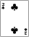 |  |  |  | 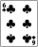 |  |  |  |  | 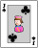 | 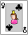 | 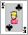
Diamonds | 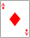 | 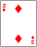 | 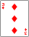 | 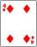 | 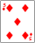 | 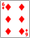 | 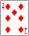 | 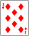 | 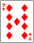 | 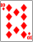 | 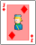 | 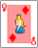 | 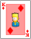
Hearts |  | 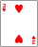 | 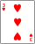 | 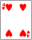 | 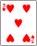 | 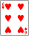 | 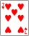 | 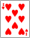 | 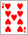 | 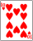 | 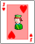 | 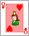 | 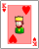
Spades |  | 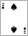 | 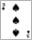 | 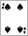 | 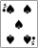 | 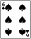 | 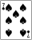 | 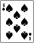 | 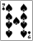 | 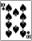 | 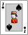 | 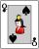 | 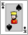
Standard Deck of Cards = 52 cards TOTAL 4 suits of 13 cards each 2 red suits/ 2 black suits=26 cards each Face cards=K, Q, J

